Experiment 7

Aim: To read a captured video in Python and display the video in slow motion and fast motion using OpenCV.

Algorithm:
- Import OpenCV.
- Read the captured video.
- Read the video frame by frame.
- Display the original video.
- Add a larger delay to create slow motion.
- Add a smaller delay to create fast motion.
- Release the video and close all windows.

Program
import cv2
cap = cv2.VideoCapture("video.mp4")
while True:
ret, frame = cap.read()
if not ret:
break
cv2.imshow("Video", frame)
key = cv2.waitKey(100) & 0xFF
if key == ord('q'):
break
cap.release()
cv2.destroyAllWindows()
Output
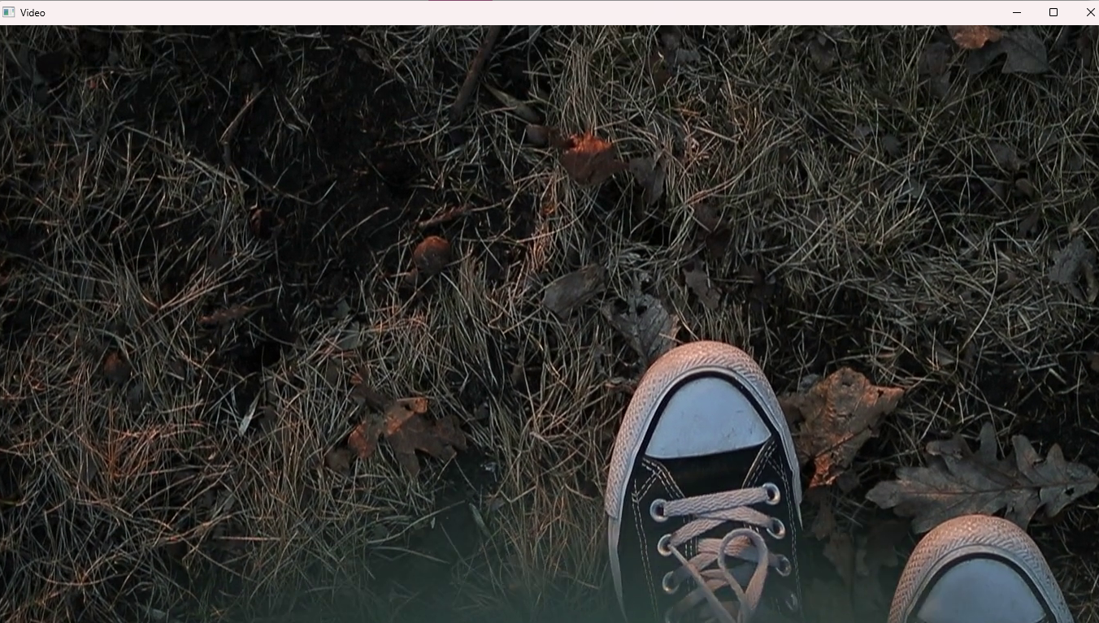

Result: Thus, the captured video was successfully read and displayed with different playback speeds using OpenCV.

